|  |
| --- |
| **Project1 - Buyer/Seller match making website**  Peer Review Document |

**JIAJUN HE: Development Team**

My role throughout this project has mainly been to develop code, server deployment, debugging, teaching and helping team members to solve their coding problems, as well as contributing to the ongoing discussions about the project and problem solving.

I developed functionalities and its corresponding layout of the website excluding the search function, initial ‘edit’ functionality and ‘delete’ functionality. I debugged all errors occur during unit test and deploy the final version of the application to the server.

Tasks I have completed throughout the unit include:

* UI website design
* Server setup and deployment
* Managed the online version of the project on Amazon’s AWS
* Manage Github repository
* Initial Laravel research and edited an installation guide
* Implementing reCAPTCHA API calls
* Database design and migration
* Debugging errors
* Frontend coding includes “User Login”, “Register”, “Home”, “Create post”, “Description”, “User detail” “Admin login”, “Admin home” and “Post/User table” page.
* Backend coding includes “User Login/out”, “Register”, “Create post”, “View Account profile/post detail” “Admin login” “Admin delete user/post”
* Part of Documentation: “User story”, “Product backlog”, “Tool setup guide”

I assisted the project team in various tasks such as:

* Backend “Delete” and “Edit” functionality
* Laravel project installation and setup
* Documentations

**Jason Le: Development Team / Team Leader / Tester**

My role throughout this project; as Team leader, was to discuss tasks that were to be done and task allocation among the team, actively participating in discussion about the project, which includes some design and structures of function implementation, as well as problem solving of issues.

As development, I was in charge of handling the search function of the website which included in research of a method to allow a flexible search option. Research led to the use of a package called “TNTSearch” that allowed us to implement the use of an index to improve search standards. This allowed me to help my team members install and improve their knowledge of this technique if they were to implement this in the future.

As the team tester, I was in charge of testing our website week by week to look out for bugs and improvements on the website. I have also taught the other members how to report bugs and methods to look for bugs to allow us to fix them during the debugging stage. Documentation of testing was recorded on Lean testing website, which later was export into a spreadsheet with some format editing.

Tasks I have completed throughout the unit include:

* Development of search function and display
* Research on index search methods
* Keep track of upcoming tasks to be completed within time frame
* Testing website and functions
* Laravel research
* Task discussion
* Planning with team members
* Test documentation
* Monitoring Lean Testing and logging test results

I assisted in various tasks such as:

* Minor debugging
* Recording minutes
* Documentation

**Pavitra Vathsalaraj: Development Team/Documentation**

In this project I have contributed in various sections, and during the course of this project I had to do a lot of prior reading, researching and learning. Laravel was a new framework and I was not familiar with the functionalities, so it took a lot of time learning.

Throughout this project my role was to do documentation, front end design (UI website design), developed delete functionality which required a lot of prior learning and research before completion. I was also responsible of setting the meeting schedule and location each week and tracking what each member has done in-between each meetings.

Tasks I have completed throughout the unit include:

* Recording meeting minutes for each meeting
* Create Gantt chart
* Scheduling each meeting time and location
* UI website design
* Layout
* Planning with team members
* Development of delete functionality
* Keep track of upcoming tasks to be completed within time frame
* Laravel research
* Task discussion
* Lean testing and reporting

**Saelon Kim: Development Team / SCRUM master**

As development, I contributed front end design and developed some functionalities. Also I contributed testing and bug reports.

My role throughout this project; as SCRUM master, I had weekly conversation with group members and a coordinator, I recorded new plans in Trello and put name into each plans what each member should do. I discussed about delayed schedule and finished schedule with team members and a coordinator. With team members and a coordinator, I discussed how to solve scheduling problems and planned new schedule in Trello.

Tasks I have completed throughout the unit include:

* Laravel research
* Task discussion
* Planning with team members
* Put schedules in Trello every week
* Keep track of upcoming tasks to be completed within time frame
* Development layouts for Create post, Edit post
* Development functionalities for Account detail, Edit profile, Change password, Edit description
* Testing website and functions
* Test documentation

I assisted in various tasks such as:

* Minor debugging
* Recording minutes
* Documentation

**GitHub**

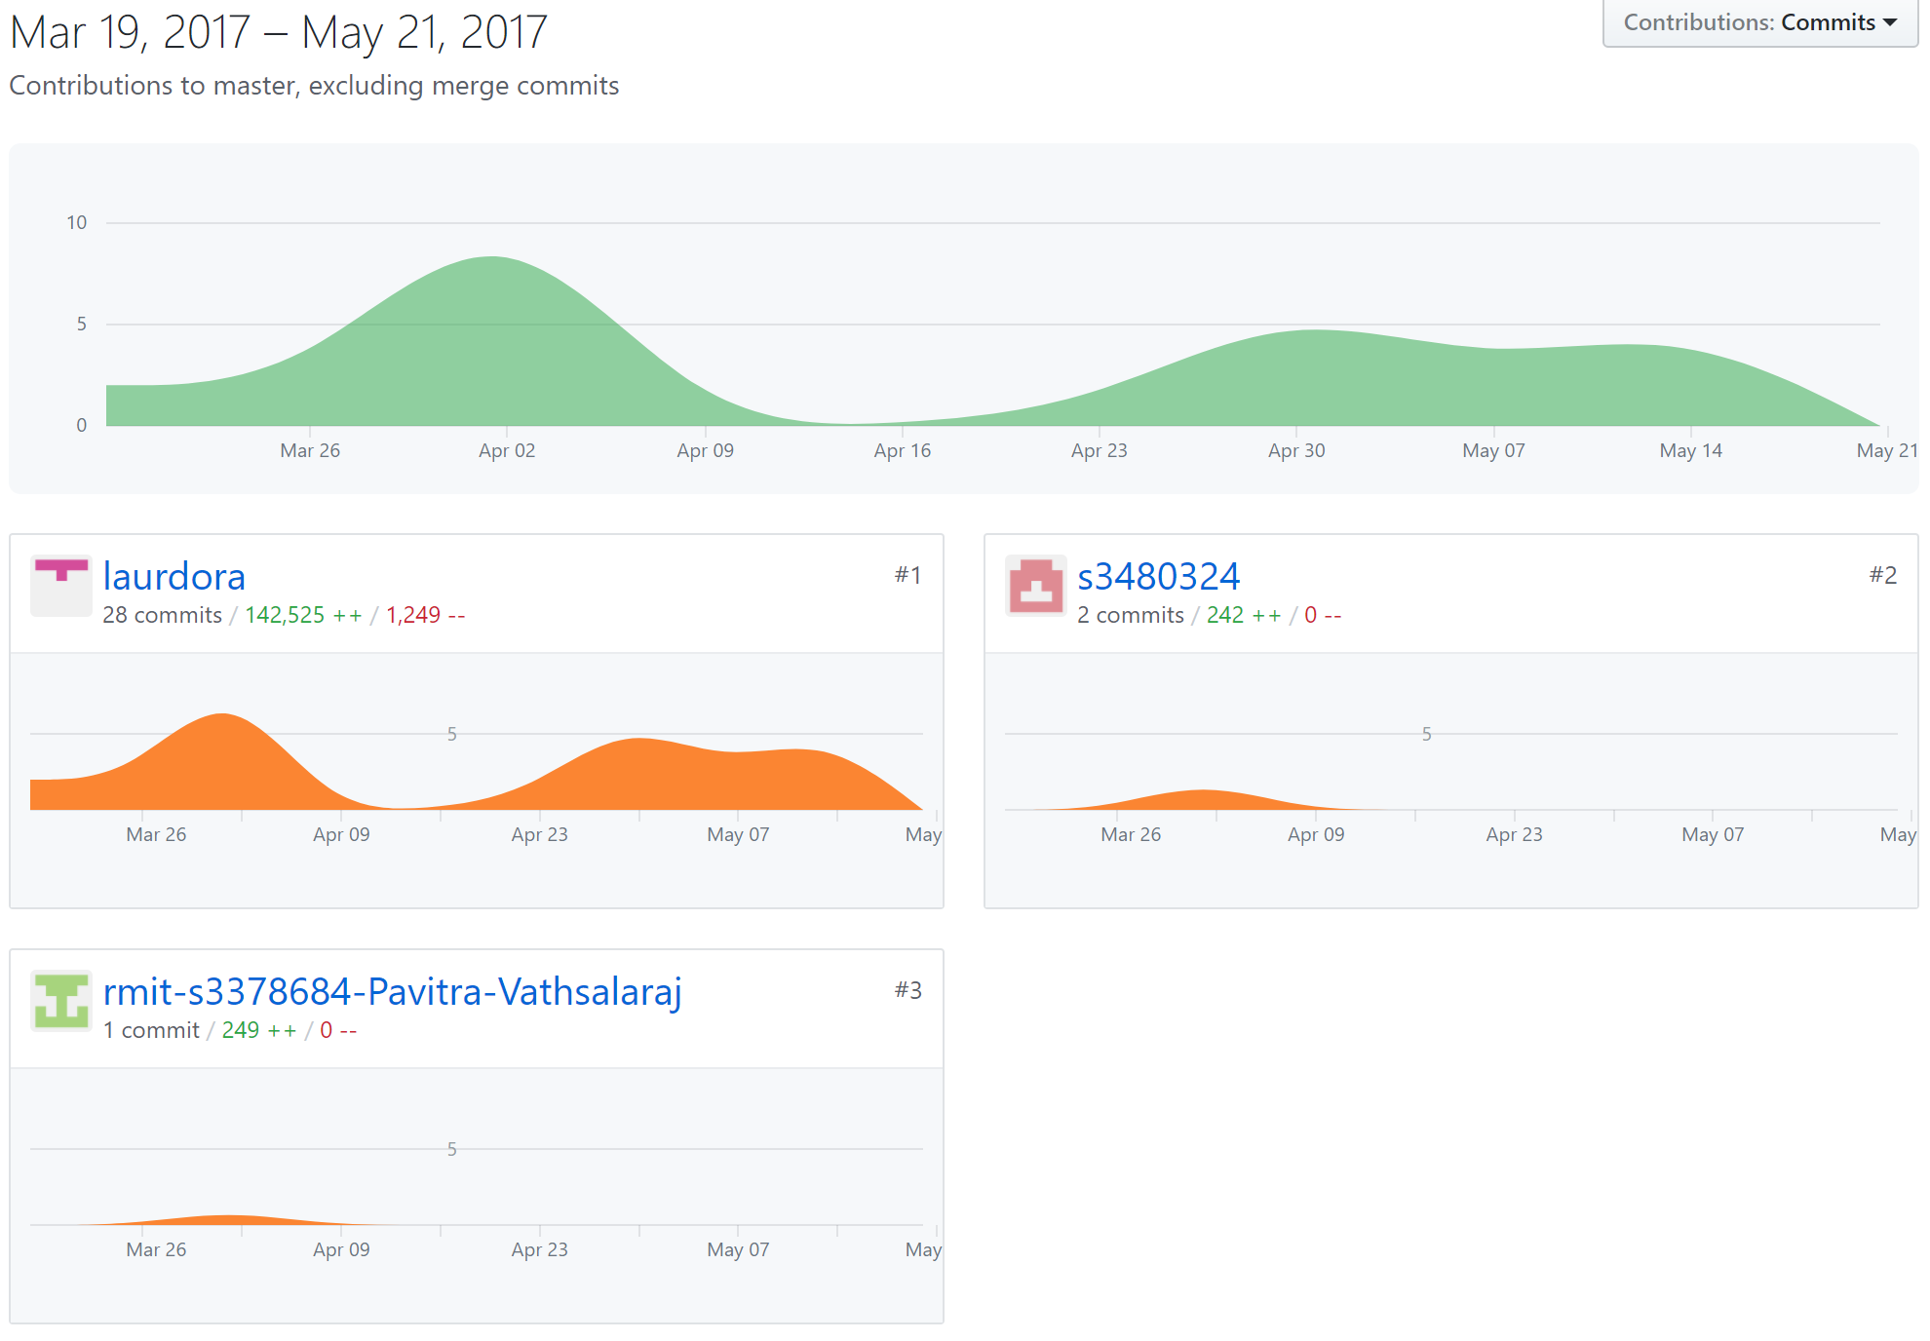

Note: Our team were new to the use of github and the contribution chart might be inaccurate. Two members, Kim and Pavitra actually have contribution during the semester not only in between March and April. Our team member Jason was missing on this chart due to an ongoing issue with GitHub which commit can not be synchronized to the remote repository.

Our commits can instead be found under the commits history page at:

Jiajun HE: <https://github.com/laurdora/project1/tree/Victor>

Saelon KIM: <https://github.com/laurdora/project1/tree/Kim's-branch>

Pavitra Vathsalaraj: <https://github.com/rmit-s3378684-Pavitra-Vathsalaraj/project1/commits/rmit-s3378684-Pavitra-Vathsalaraj-patch-1>

Jason Le: <https://github.com/laurdora/project1/commits/Jason>